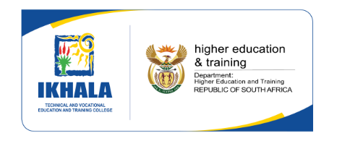

_________________________________________________________________________________

**ORIENTATION FOR ENGINEERING STUDENTS**

**N2, N3 AND N4**

**03 JUNE 2024**

**09:00**

**VENUE: WORKSHOP**

**___________________________________________________________________**

**PROGRAMME**

Opening & Welcome Mrs. Kolanisi

Presentations Mrs. Kolanisi

Bursaries Mr. Mtshengu

Career Guidance Councillor Me. Sanda

SRC SRC Chairperson

**Campus Tour for new students**

Mr. Jama, Mr. Nkqayi, Mrs Mpompi

**_________________________________________________________________________________________**